**Curriculum pathway:**

**DT Year 4**

**Summer Term – The Great Escape**

**CAD**

**Rusk biscuits**

**Key Vocabulary:**

Computer aided - Done or improved by computer

Packaging - Contains or holds together products that would otherwise be difficult to carry

Net - What a shape looks like if it is opened out flat

Accurate - Exact and true

Replicating - To produce one or more exact copies of itself

Hand-made – Made by a person not by a machine.

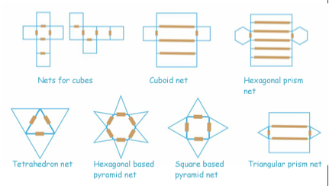

**Key Facts:**

Computer aided design can be used to make products that are difficult to do by hand

CAD is useful for when we want to make more than one item because they will all look exactly the same

2D nets can be used to make packaging for 3D products

Packaging is often bright and colourful to attract people’s attention in shops

**Key Questions:**

What is CAD?

What are the benefits of using computers rather than creating by hand?

What is a 2D net?

How does packaging for food help to sell a product?