**Curriculum pathway:**

**Key Vocabulary:**

Lasagne - Broad flat noodles baked with a sauce usually of tomatoes, cheese, and meat or vegetables

Savoury - Salty or spicy and not sweet in taste

Food mile - The distance food has travelled to get to your plate

Seasonality - Different foods grow better at different times of the year

Climate - The weather found in a certain place over a long period of time

Import - Goods coming in to the country

Export – Goods going out of the country

Environment - All the physical surroundings on Earth

**DT Year 6**

**Summer Term – Back to our Roots**

**Culture and seasonality**

**Ready Steady Cook**

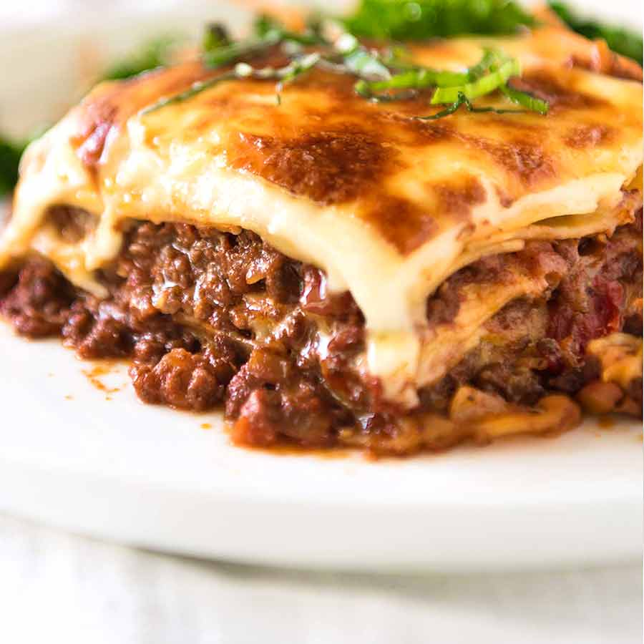

**Key Facts:**

A lasagne is an Italian dish dating back to the middle ages

Lasagne was originally a vegetarian dish

The earliest lasagne recipes known are dated from the thirteenth century. At that time, tomatoes were not known to Europeans. This means that they couldn’t have used them in the recipes.

Lots of ingredients cannot be grown/produced in the UK because of our climate so they are imported from other places in the world

Food miles is a way of measuring the environmental impact of the ingredients we use in our diets. It is based on the distance from the origin country to our own.

**Key Questions:**

Where does our food come from?

Why can’t we get it all from the UK?

What is a lasagne?

Why is lasagne a popular dish in the UK?

What does savoury mean?

What are food miles?

What impact does importing and exporting ingredients have on the world?