**Curriculum pathway:**

**Key Vocabulary:**

Alarm - A device that warns or signals by a bell, buzzer, or whistle

Current - The rate at which electrons flow past a point in a complete electrical circuit

Circuit - A complete path around which electricity can flow

Bulb - The glass part of an electric lamp, which gives out light when electricity passes through it

Buzzer - An electric signalling device that makes a buzzing sound

**DT Year 6**

**Spring Term – Journeys**

**Electrical components**

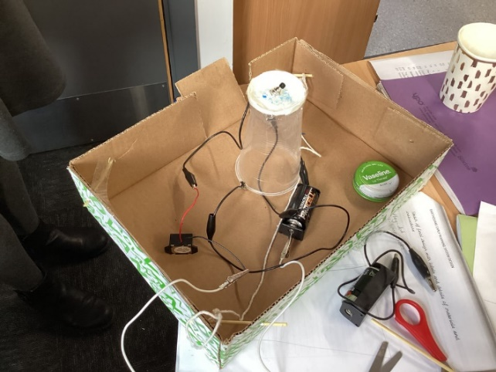

**Key Questions:**

Why do we need alarm systems?

What causes alarms to go off?

What types of switches can be used and why?

What is an input and an output?

**Key Facts:**

Alarm systems are designed to make a loud noise when they are set off to alert people of something

We can alter what input causes an output in a circuit by using a range of different switches and resistors.

Push to make switches complete a circuit when they are pressed but stop when released.

Push to break switches complete a circuit when they are pressed and released.

Light dependent resistors allow current to flow through them when there is an input of enough light.