**Curriculum pathway:**

**Key Vocabulary:**

Conductor - Materials that electricity can flow through easily  
Insulator - A material which does not easily allow heat and/or electricity to pass through it

Switch - A switch is used to make or break a complete circuit

Wire -A long, thin and flexible piece of metal

Conceal - Cover or keep from sight

Current - A steady flow of electrons

Battery - A sort of container that stores energy until it is needed

Cell - Electrical power supply

**DT Year 4**

**Spring Term – 17th Century Britain**

**Simple electrical components**

**Pizzas and Apple crumble**

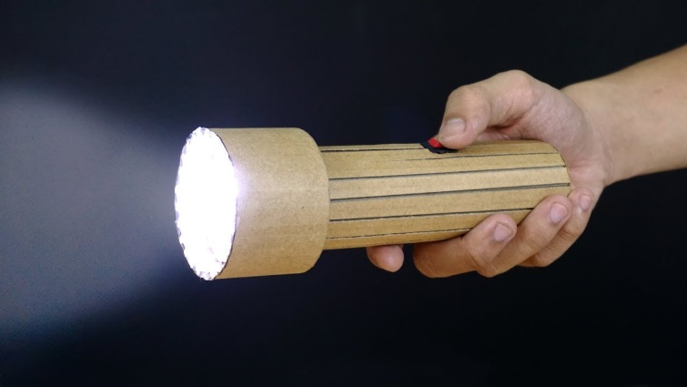

**Key Facts:**

An electric switch is used to control the flow of an electric current.

If the switch is allowing the current to flow, the electric item will be on.

If it is not allowing it to flow, the electric item will be off.

To make a switch, we need to use materials which are conductors so that the electricity will pass through.

**Key Questions:**

What is the purpose of an electric switch?

Which materials should we use to make our switch?

What different types of switches are there?

How can we conceal our circuits?

How do we make sure our circuit is safe?