**Curriculum pathway**

**Key Vocabulary:**

Shelter - What people and animals use to protect themselves from their surroundings

Sturdy - Looks strong and is unlikely to be easily injured or damaged

Corrugation - The act of shaping into parallel ridges and grooves

Reinforce - To strengthen by additional assistance, material, or support

Bombing - To attack with or as if with bombs

Kit - A collection of things used for a certain purpose

**DT Year 6**

**Autumn Term – Fighting fit**

**Sturdy structures**

**Ration Packs**

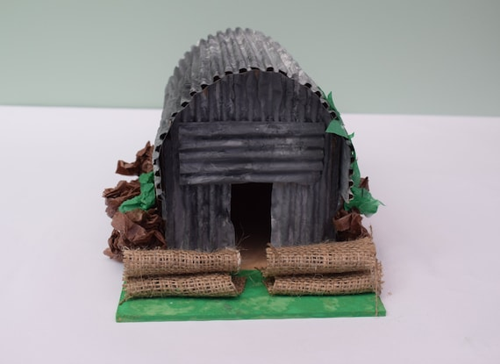

**Key Facts:**

The government gave an Anderson Shelter kit to families who lived in areas that were expected to be bombed by German planes.

They were often made from corrugated metal frames dug into the ground

They had to be very sturdy to withstand the impact of nearby bombs

Corrugating a material helps it to carry more weight

**Key Questions:**

What effect does corrugating a material have?

Can we make materials waterproof?

How can we reinforce our structures?