**Curriculum pathway:**

**Key Vocabulary:**

Puppet - A figure that is moved by a person, usually for a performance of some kind

Felt - A heavy material made by rolling and pressing fibres together

Plastic - Material that is made by people and can be formed into almost any shape

Thread - Twisted fibres made from cotton, silk, or other material, that can be used in sewing

Paper - A thin material that people use for writing, printing, wrapping, and many other purposes

Card - A flat stiff usually small and rectangular piece of material

Stitch - Loops of thread that are used to join the edges

Staple - A fastener that is usually made out of metal

Tape - A sticky strip of material you can use for fastening paper or other light objects

Stick - Attach it using glue

**DT Year 2**

**Spring Term – My Country, My City**

**Making hand puppets**

**Yorkshire puddings**

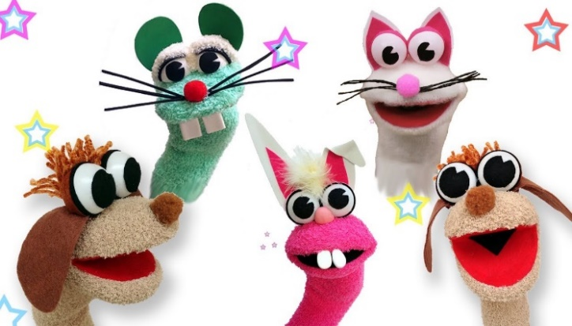

**Key Facts:**

The head and hands of a hand puppet can be made of materials that are either solid or flexible.

Hand puppets usually have no legs; when they do have legs, these hang limply without being controlled.

We can materials together using staples, safety pins, glue, tape, stitching (running stitch)

**Key Questions:**

What are puppets?

What are puppets made out of?

Which materials can be used to make puppets?

How can puppets be moved?

How can we join fabric together?