**Curriculum pathway:**

**Key Vocabulary:**

Purse – An object to carry money

Wallet - A small flat folding pocketbook with compartments

Fastener - A device that attaches one thing to another or holds something in place Velcro - tiny loops on strip of woolly fabric catch onto tiny hooks of an opposite strip of same material

Zip - Two rows of metal or plastic teeth-like parts that are brought together by pulling a small sliding piece over them, used for closing openings in clothing

Button - A small, flat, round object often found on clothing

Fashionable – Clothing that is in style

Secure – To fix something together

**DT Year 4**

**Autumn Term – Our Magical City**

**Product with a fastening**

**Smoothies and cupcakes**

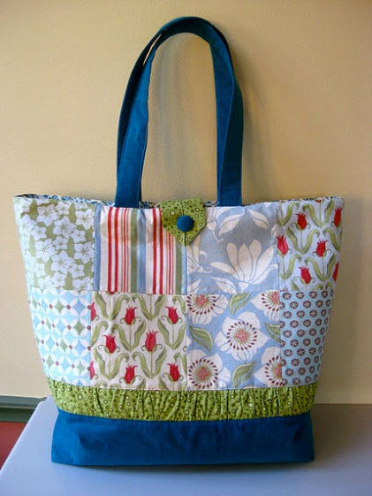

**Key Facts:**

Fasteners are used to close textile products

Types of fastening include velcro, zips, buttons

People usually keep money and cards in their purses/wallets

They need to be secure so money doesn’t fall out

Purses and wallets are also seen as fashion items so people want them to look attractive

**Key Questions:**

What is a fastening?

What types of fastening are there?

What is the purpose of a purse/wallet?

What materials would we use for the product?