**Curriculum pathway**

**Key Vocabulary:**

Compass – A tool for finding direction

Direction – The line or course along which something moves or points

Continent – A large solid area of land

**Geography Year 2**

**Autumn Term – The History of Flight**

**Continents of the world**

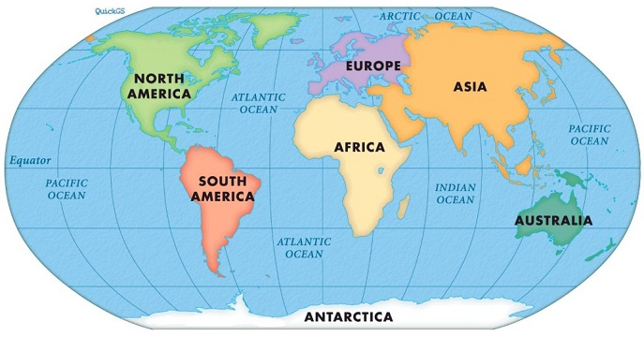

**Key Facts:**

The seven continents are Antarctica, North America, South America, Europe, Asia, Australia and Africa.

Amelia Earhart crossed the Atlantic and Indian Oceans.

**Key Questions:**

What are the seven continents called?

Which continent do I live in?

Can I locate the seven continents on a map?

What oceans did Amelia Earhart cross?

What are the human and physical features of a continent?