**Curriculum pathway**

**Key Vocabulary**

Globe – A spherical model of Earth

Atlas – A book that shows different maps

**Geography Year 1**

**Spring Term – Eco Warriors**

**Geography of the World**

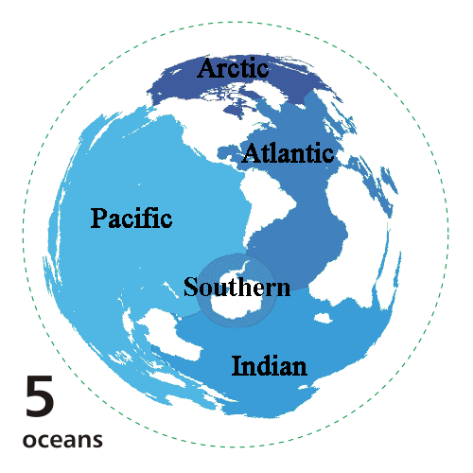

Sustainable development goals

**Key Facts**

The five oceans are Arctic, Atlantic, Indian, Pacific and Southern.

**Key Questions:**

What are the five oceans called?

Where am I in the world?

Where are the 5 oceans in the world?

What does earth look like from space?