**Curriculum pathway:**

**Key Vocabulary:**

Rural – Countryside rather than town

Urban – Areas where many people live and work

Landscape – Area of land as you can see it

Renewable energy – Energy from natural sources

Non-renewable energy – Energy that will run out and not be replaced

Coal – Black rock that is formed from decayed plants that were trapped underground millions of years ago

Oil – A liquid found deep underground

Gas – One of the tree states of matter

Wind turbine – Tall towers topped with blades

Hydro energy – Power generated from moving water

Grid reference – Tells you where something is on a map

**Geography Year 3**

**Autumn Term – Who First Lived in Britain?**

**The Effects of Human Activity on the UK’s Landscape**

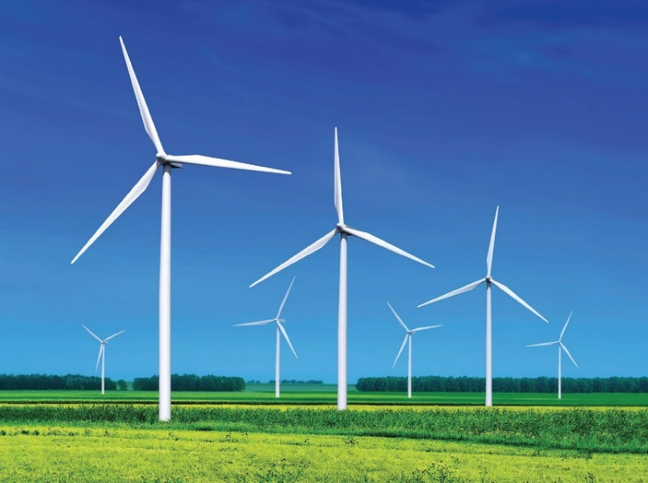

**Key Questions:**

What are some physical features of the UK?

How do human activities affect the UK landscape?

What energy sources are used in the UK?

**Key Facts:**

Since the Stone Age Human pollution has caused water levels to rise.

Renewable energy sources produce less pollution which helps to protect the environment.

Renewable energy provides us with cleaner air and water.