**Curriculum pathway:**

**Key Vocabulary:**

Geologist – A scientist that studies the surface of the Earth and what it is made of

Geographical features – Things that can be classified as locations, sites, areas or regions.

Summit – The top of a mountain or hill

Valley – A long depression or ditch in the Earth’s surface

Base – The bottom of a mountain where it meets the ground

Face – A side of a mountain or building that is high and very steep

Ridge – A land form that consists of a chain of mountains or hills that forms peak

Gully – A trench worn in the earth by running water after rain

Sea level – The height of the ocean

Erosion – When tiny pieces of the Earth’s surface are moved from one place to another

Dormant – Not active but capable of becoming active

Expedition – A journey or trip undertaken for a specific purpose

**Geography Year 5**

**Autumn Term – Adventures**

**Mountains**

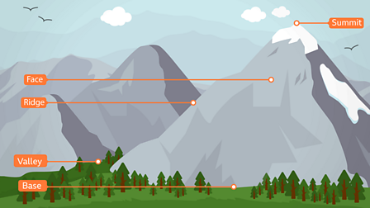

**Key Facts:**

Any land mass that rises 1,000 feet above the surrounding area is considered a mountain.

Volcanic mountains are made from ash and cooled lava.

The islands of Hawaii are actually volcanoes

The highest mountain in the world is Mount Everest in Nepal – it’s 8,850 metres high.

The tallest mountain in the world is Mauna Kea in Hawaii, USA – its base is below sea level, and when you measure from base to summit it’s over 10,000 meters tall.

In 1910, the Glacier National Park in Montana in the United States was filled with approximately 150 glaciers. When the glaciers were recounted in 2017, this number had dropped to 26.

The Kumaon region is full of mountain ranges. It is a place of attraction for tourists from all over the world.

**Key Questions:**

What is a mountain and how are they formed?

Where in the world are mountains and mountain ranges?

Why do people climb mountains?

What was the most famous mountain expedition?

Where do the Kumauni people live?

How is the life of a Kumauni child different from mine?