**Curriculum pathway**

**Key Vocabulary**

Capital City – The city which houses central government

Country – A land controlled by a single government

City – Largest kind of settlement

Town – A settlement that is smaller than a city

Village – A settlement in the countryside

Beach – The land at the edge of the ocean

Forest – A large area covered in trees

Hill – A piece of land that rises higher than everything around it

Mountain – Higher and steeper than a hill

Sea – A great body of salty water smaller than an ocean

Ocean – A huge body of salt water

River – A flowing stream of water leading to the sea, lake or another river

Office – A room or other area where work is done

Port – A place where boats can come and go to load and unload

Harbour – An area of the sea at the coast enclosed by land or walls

**Geography Year 1**

**Autumn Term – Castles**

**The United Kingdom**

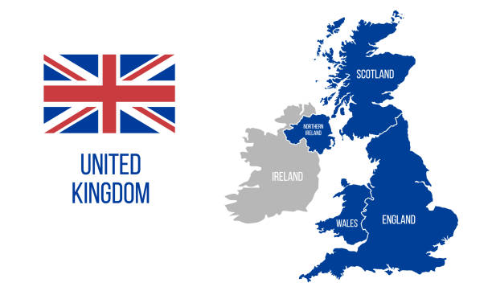

Experiences

**Key Facts**

The biggest castle in England is Windsor Castle.

The official name of the UK is ‘The United Kingdom of Great Britain and Northern Ireland’.

The UK is made of four countries which are England, Ireland, Scotland and Wales.

King Charles III lives in London and is the King of the UK.

The official London home of the King is Buckingham Palace.

There are four different capital cities in the United Kingdom which are London - the capital of England; Edinburgh - the capital of Scotland; Cardiff - the capital of Wales and Belfast - the capital of Northern Ireland.

**Key Questions**

Where are the castles in the UK?

What are the four capital cities of the UK?

What four countries is the UK made up of?

Which sea surrounds the UK?

What are physical features?

What are human features?

Which country do we live in?

Which city do we live in?

What is the official name of the UK?