**Curriculum pathway:**

**Key Vocabulary:**

Trade – The buying and selling of goods and services

Canal – A waterway that is man-made and used for shipping and travel

Fieldwork – When you go outside and find out things about a place

Sketch map – Simple drawings of the landscape

Bird’s eye view – A view of something from above

Towpath – A path along the side of a canal

**Geography Year 4**

**Autumn Term – Our Magical City**

**Local Settlements – Saltaire**

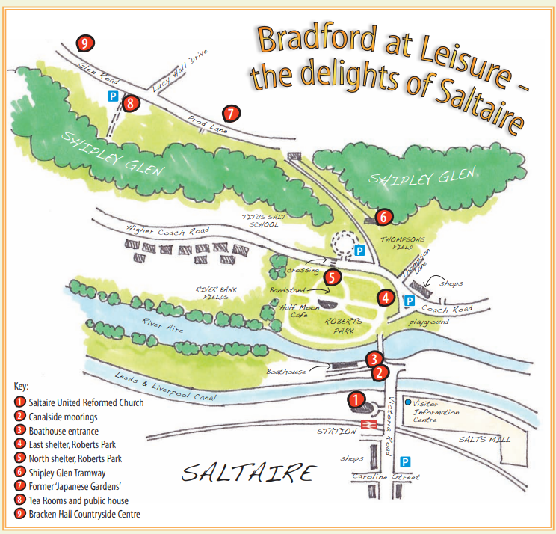

**Key Facts:**

Salts Mill is built on a canal that connects Saltaire to Leeds and Liverpool.

Sketch maps are simple drawings of the landscape.

Sketch maps may be shown as a bird's-eye view or as a drawing of the horizon.

**Key Questions:**

Why did Titus Salt choose to build a factory in Saltaire?

What are the human and physical features of Saltaire?

What is a sketch map?