**Curriculum pathway:**

**Key Vocabulary:**

Latitude – Horizontal imaginary parallel lines around the Earth

Longitude - Vertical imaginary parallel lines around the earth

Northern Hemisphere – The section of the Earth north of the equator

Southern Hemisphere – The section of the Earth south of the equator

Tropics – a region of the Earth’s surface which is closest to the equator

Polar region – at the top and bottom of planet Earth

Biome – A large place that has its own specific plants, animals, temperature, soil and rainfall.

Desert – A place that has very little rainfall

**Geography Year 3**

**Spring Term – Here, There and Everywhere**

**Longitude, latitude, climate zones and biomes**

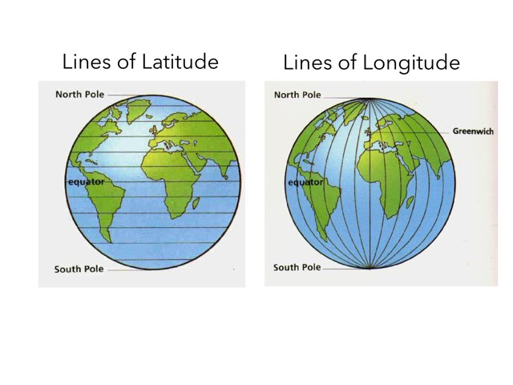

**Key Facts:**

Lines of latitude and longitude are invisible lines on the earth which help us to identify places on the world map.

The equator is the closet part to the sun.

Countries above the equator are part of the Northern Hemisphere.

Countries below the equator are part of the Southern Hemisphere.

Examples of biomes include rainforests, forests, oceans, grasslands, savannahs, polar regions and deserts.

**Key Questions:**

What are the lines of latitude and longitude?   
Why do countries have different climates?  
Why do we have different time zones?

What is a biome?

What are the characteristics of polar region biomes?

What are the characteristics of desert biomes?