**Curriculum pathway:**

**Key Vocabulary:**

Coast – The area where the sea and land meet

Coastline – The boundary between sea and land

Shore - The land along the edge of a sea, lake, or other large body of water.

Resort - A place that is visited for holidays

Promenade - A walkway along the seafront

Cliff - A steep rock face, especially at the edge of the sea.

Human features – Things made by humans

Physical features – Anything that is on the Earth naturally

Bay - A broad inlet of the sea where the land curves inwards.

Shingle - A mass of small rounded pebbles, especially on a seashore.

Pier - A platform on pillars projecting from the shore into the sea, typically with entertainment arcades and places to eat.

**Geography Year 2**

**Summer Term – Oh I do Like to be Beside the Seaside**

**Seaside features and contrasting locations**

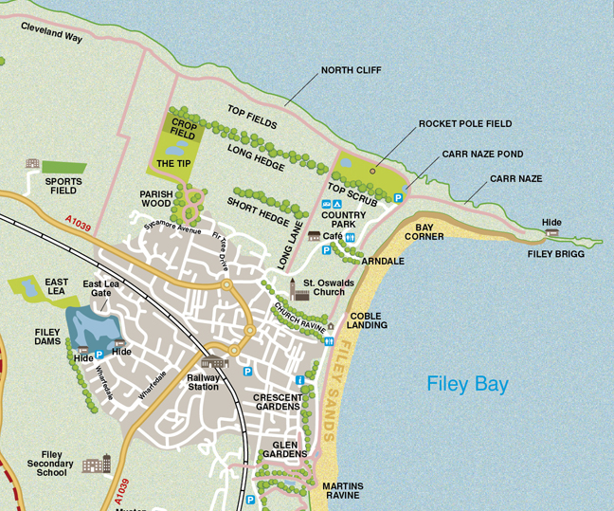

**Key Facts:**

Filey beach is 5 miles long

The UK coastline is over eleven thousand miles in total

In some countries, it is always nearly always hot or always cold.

**Key Questions:**

What is the seaside?

What are the human and physical features of the seaside?

Why do people go to Filey?

How is Filey different to Sharm-el-Sheikh?