**Key Vocabulary:**

Habitat – places where animals and plants live

Subcontinent - A large part of a continent

Tropical – Warm or hot throughout the year

Moist – Slightly or moderately wet

Climate – The average weather conditions in a place

Temperature – The amount of heat in something

Monsoon – The wind pattern that causes summer rain

Vegetation – All plants and trees

Population – The number of people living in a certain place

State – An alternative name for a county

Equator – The imaginary line around the middle of the earth

**Curriculum pathway**

**Geography Year 1**

**Summer Term – Incredible India**

**Comparing Goa to Bradford**

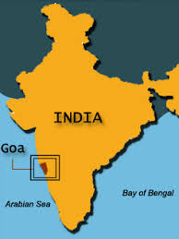

Experiences

**Key Questions:**

Where are the hot and cold places on a map?

Where is Goa in India?

What is special about this city?

What are the features of Goa?

Which animals live in Goa and how do they adapt to their climate?

How is Goa different to Bradford?

**Key Facts:**

The imaginary line in the middle of the Earth is known as the Equator.

The countries closer to the equator are warmer and the countries further away are the coldest.

Goa is India’s smallest state.

In Goa, you would find Indian civet, the sloth bear, the Indian porcupine, the pangolin, the slender loris, the wild boar and the mongoose.