**Curriculum pathway:**

**Key Vocabulary:**

Aerial photograph – Any photograph taken from the air

Oblique Photograph – A photograph taken on an angle

Boundary – A real or imaginary line that separates two places

Scale – A ratio between two sets of measurements

Ratio – Compares one thing to another

**Geography Year 3**

**Summer Term – Greeks**

**Comparing a UK city with a European city**

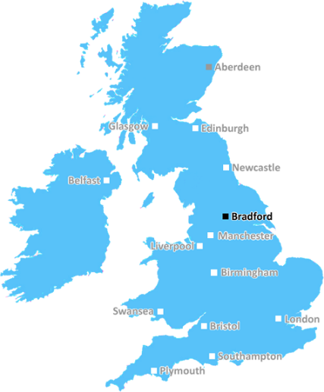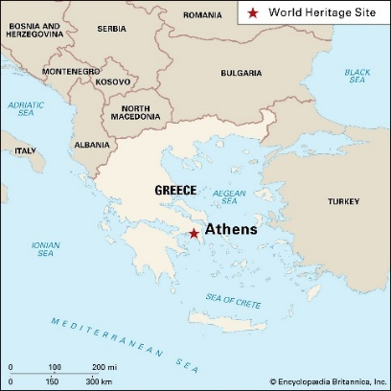

**Key Facts:**

Greece is one of the most mountainous countries in Europe.

The capital city of Greece is Athens.

**Key Questions:**

What are the similarities between Bradford and Athens?

What are the human features of Greece?

What are the physical features of Greece?