**Curriculum pathway:**

**Key Vocabulary:**

Scale - The ratio of the distance on the map to the distance on the ground and it shows what 1 cm on the map represents in the real world

Ratio - Compares one thing to another thing

Economy - The way people spend money and the way people make money

Trade link - Trade happens between businesses and countries across the globe

**Geography Year 5**

**Summer Term – The Industrial Age**

**Land Use and Settlements**

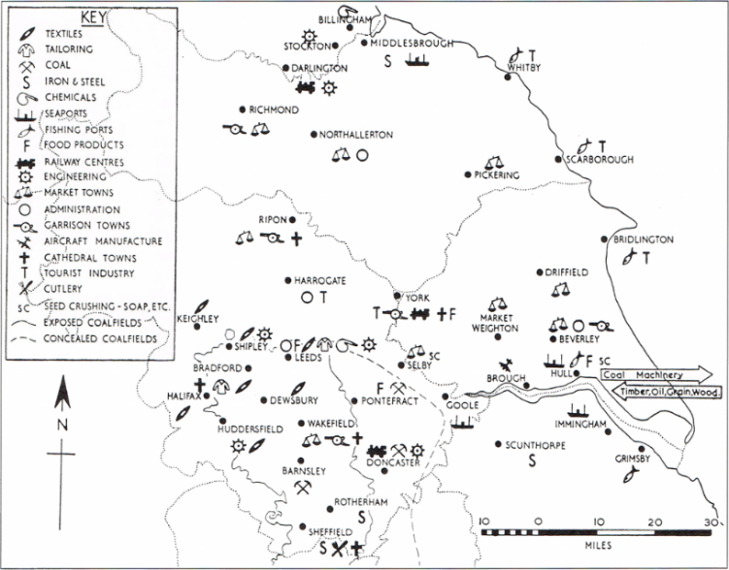

**Key Questions:**

How did the railways affect trade during the Industrial Age?

What caused the spike in population during the Industrial Age?

What is the difference between a primary and a secondary source?

How did Bradford’s landscape change over the course of the Industrial Revolution?

What effect did the Industrial Age have on climate change?

**Key Facts:**

In 1830 Robert Stephenson implemented the first ever passenger service in the world, which took travellers from Canterbury to the seaside town of Whitstable 6 miles away.

In 1863 the first underground service was built, connecting London Paddington to Farringdon.

 Before the Industrial Revolution, Bradford was a small market town with a population of 4500. By 1850, the population had grown to 103,000.

Human geography is the branch of geography that is associated and deals with humans and their relationship with communities, cultures and economies.