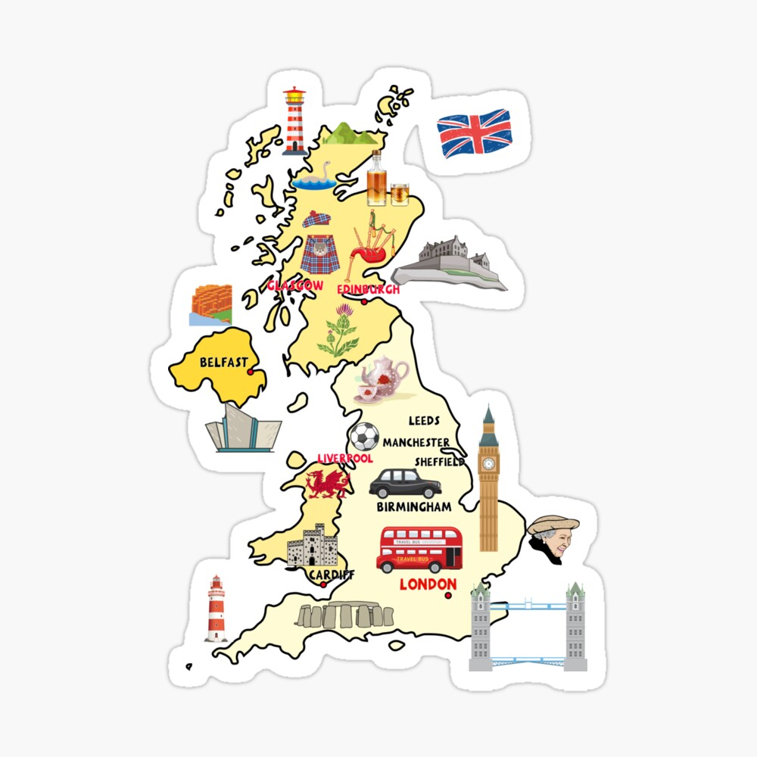

**Curriculum pathway:**

**Key Vocabulary:**

Commonwealth – An international organisation of 54 countries including the UK

Migration – A long journey to a new home

Immigration – The process of moving to a new country

Landmark – Features around the world that are easily recognised

Stream – A small, narrow river

Waterfall – A body of water’s steep fall over a rocky ledge

Lake – A body of water surrounded by land

Moorland – Open land usually with peaty soil and moss

Gorge – A narrow valley, with steep rocky walls, located between hills or mountains.

**Geography Year 5**

**Spring Term – Beautiful Britain**

**UK Geography**

**Key Facts:**

The current population of London, England’s capital city, is 9.54 million.

There are hundreds of landmarks in the UK. The oldest – Knap of Howar – was built in 3700BC.

**Key Questions:**

What is the commonwealth?

Which countries have a monarch?

How many regions are there in Britain?

Why do people move to different areas?

How has the population of the UK changed?

Why do people come to live in the UK?

What are some popular tourist destinations in the UK?

What are some of the UKs most famous landmarks?