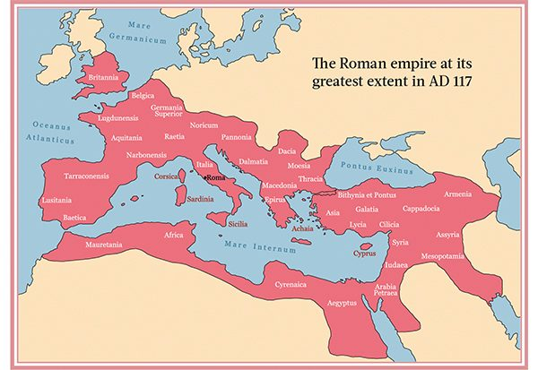

**Curriculum pathway:**

**Key Facts:**

Boudicca was a warrior queen of the Iceni people.

Boudicca led the Iceni people in a revolt against the Roman rule.

The Romans spoke Latin.

Much of our language today comes from Latin.

Romans created towns.

Romans introduced drainage and aqueducts.

**Key Questions:**

Who lived in Britain before the Romans invaded?

Who was Boudicca?

Why was there a rebellion?

How have the Romans impacted on our lives today?

**History Year 4**

**Summer Term – The Great Escape**

**The Roman Empire**

**Key Vocabulary:**

Legion - a vast number of people or things.

Rebellion - an act of armed resistance to an established government or leader

Invasion - an instance of invading a country or region with an armed force

Aqueduct - an artificial channel typically in the form of a bridge across a valley or other gap