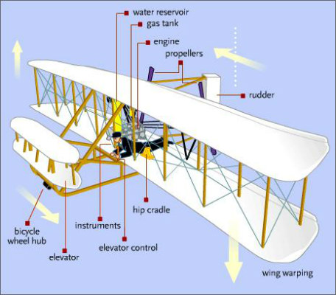

**Curriculum pathway:**

**Key Facts**

The Wright Brothers, Orville Wright and Wilbur Wright were born in Dayton, Ohio.

They designed, built and flew the first engine powered aeroplane in December 1903.

They had been experimenting for many years with gliders and other vehicles before the first powered flight.

They were also known for inventing a way to steer an aeroplane.

The Wright Brothers were interested in flights and started making aeroplanes in their bicycle shop.

The Wright Brothers invented wing warping to control the wings.

Amelia Earhart became the first woman to fly solo across the Atlantic Ocean.

Amelia Earhart was the first person to fly solo from Hawaii to the United States.

**Key Questions**

What is transport?

What transport was used in the past?

What means of transport do we use now?

What are the Wright brothers famous for?

How was the Aviation changed after Wright Brother’s invention?

What was Amelia Earhart famous for?

What problems did Amelia Earhart encounter?

What impact has she had on society today?

**History Year 2**

**Autumn Term – History of Flight**

**The Wright Brothers and Amelia Earhart**

**Key Vocabulary**

Transport – To move things from one place to another.

Aviation – The flying or making of an aircraft

Vehicle – A mode of transport

Aeroplane – An aircraft that has wings

Flight – The process of an object moving through air

Gliders – an aircraft that flies through the air without an engine

Steering – Controlling the direction of a vehicle

Engine – a machine that uses different parts that changes fuel into power

Wing warping – A early system for controlling the wings of an aircraft