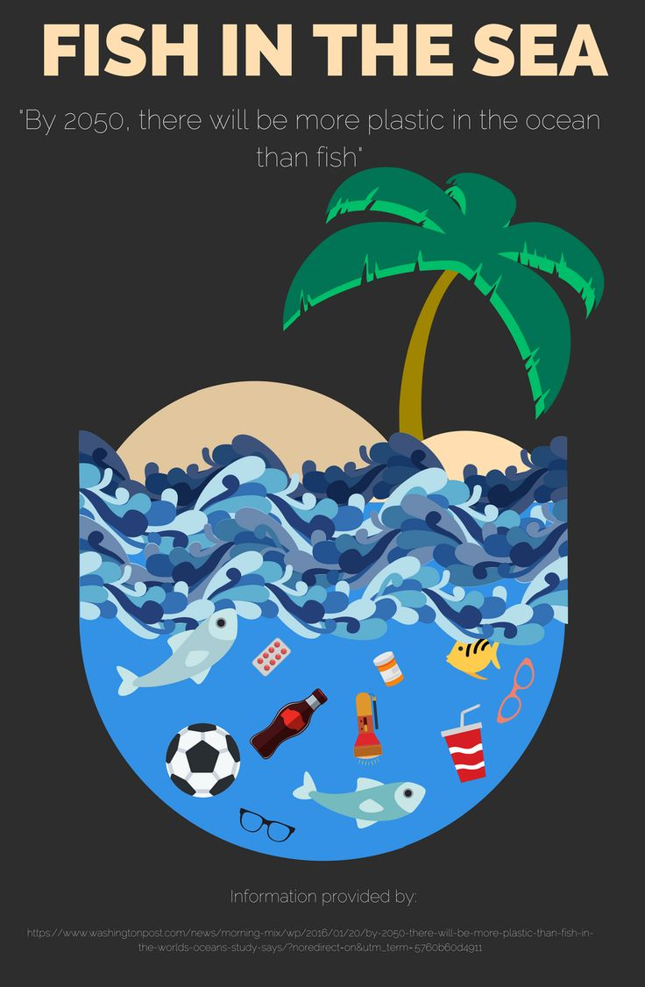

Sustainable development goals

**Curriculum pathway:**

**Key Facts**

A plastic is a kind of material that is made by people and can be formed into almost any shape.

Most plastics are strong, long-lasting, and lightweight.

Most plastics are made from chemicals that come from [petroleum](https://kids.britannica.com/kids/article/petroleum/353619) (oil), natural gas, or coal.

Plastics can be made into almost any shape by heating them at a high temperature.

In 1869 John Wesley Hyatt, a U.S. inventor, made the first plastic.

Plastics are very useful, but they can also cause many problems for the [environment](https://kids.britannica.com/kids/article/environment/399445) if they end up in the oceans .

Items made out of plastic do not break down and take up room in landfill.

**History Year 1**

**Spring Term – Eco Warriors**

**The Invention of Plastic**

**Key Vocabulary**

Invention – Something that has been newly created

Formed – Combine parts to make something new

Lightweight – Thin material that weighs less than normal

Petroleum – A technical word for oil

Environment – The place in which a person, animal or plant lives

Plastic – A manmade material from chemicals

Chemicals – Something that cannot be broken down without changing into something else

Material – What objects are made from

Natural gas – Is formed deep underground

Landfill – A big hole in the ground where we bury rubbish.

Ocean – A large area of salty water covering over 70% of the earth

Oil – A natural liquid found deep underground

**Key Questions**

What does invention mean?

Who invented plastic?

What is plastic made from?

What did people use before plastic?

Why was plastic invented?

What do we use plastic for today?

What are the positives of using plastic?

What are the negatives of using plastic?