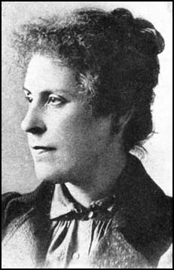

**Curriculum pathway:**

**Key Facts:**

During the Victorian era, there was a common belief that that trains could cause insanity due to their speed and the effects this had on the brain.

Bradford has the largest proportion of under-fives and under 19-year olds, and the largest average house size.

Many people worked in factories, foundries or mills.

The Victorians transformed Britain from an agricultural country to a world industrial power.

The arrival of the railways had the biggest impact on British with everything travelling faster than ever before.

Margaret McMillan **campaigned for improved conditions for children.**

Margaret McMillan created nursery education for young children.

**Key Questions:**

What was the industrial revolution?

How did Bradford change because of the industrial revolution?

How can you tell if a source of information is accurate?

Why is Margaret McMillan important?

How did the industrial revolution affect the environment?

How did the railways change during the industrial revolution?

**History Year 5**

**Summer Term – The Industrial Age**

**Victorian Britain**

**Key Vocabulary:**

Industrial - relating to or characterised by industry

Revolution - a forcible overthrow of a government or social order, in favour of a new system.

Campaigned - an organized course of action to achieve a goal.

Agricultural - the art and science of cultivating the soil, growing crops and raising livestock

1. Foundries - a workshop or factory for casting metal.