**Curriculum pathway:**

**History Year 1**

**Autumn Term – Castles**

**Queen Victoria’s Reign**



Heritage

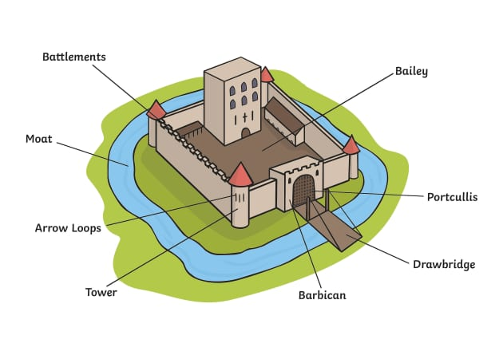

**Arrow slits**

**Turret**

**Key Facts**

Queen Victoria's reign is known as the Victorian era

Victoria was 18 when she became Queen in 1837

Queen Victoria ruled almost 64 years

Victoria would become the **longest reigning British Monarch,** and Queen of the**biggest empire in history.**

Sarah Forbes was the daughter of an African chief.

Queen Victoria paid for Sarah’s education and made sure she had everything that she needed.

**Key Questions**

What are castles?

Why were castles built?

Who was queen Victoria?

What character features helped queen Victoria to change Britain’s monarchy and society?

Why was Queen Victoria such a significant person?

Who was Sarah Forbes Bonetta and why is she remembered?

Was Sarah Forbes Bonetta a controversial figure?

Who lived in Skipton Castle?

How important was Skipton Castle to our local area?

**Key Vocabulary**

Empire – A group of countries ruled over by a single monarch

Victorian – Relating to the reign of Queen Victoria

Monarch – A king or queen

Reign – A period of rule of a monarch

Coronation – A special ceremony to crown a monarch

Throne – A special chair for a king or queen

Dungeon – An underground prison