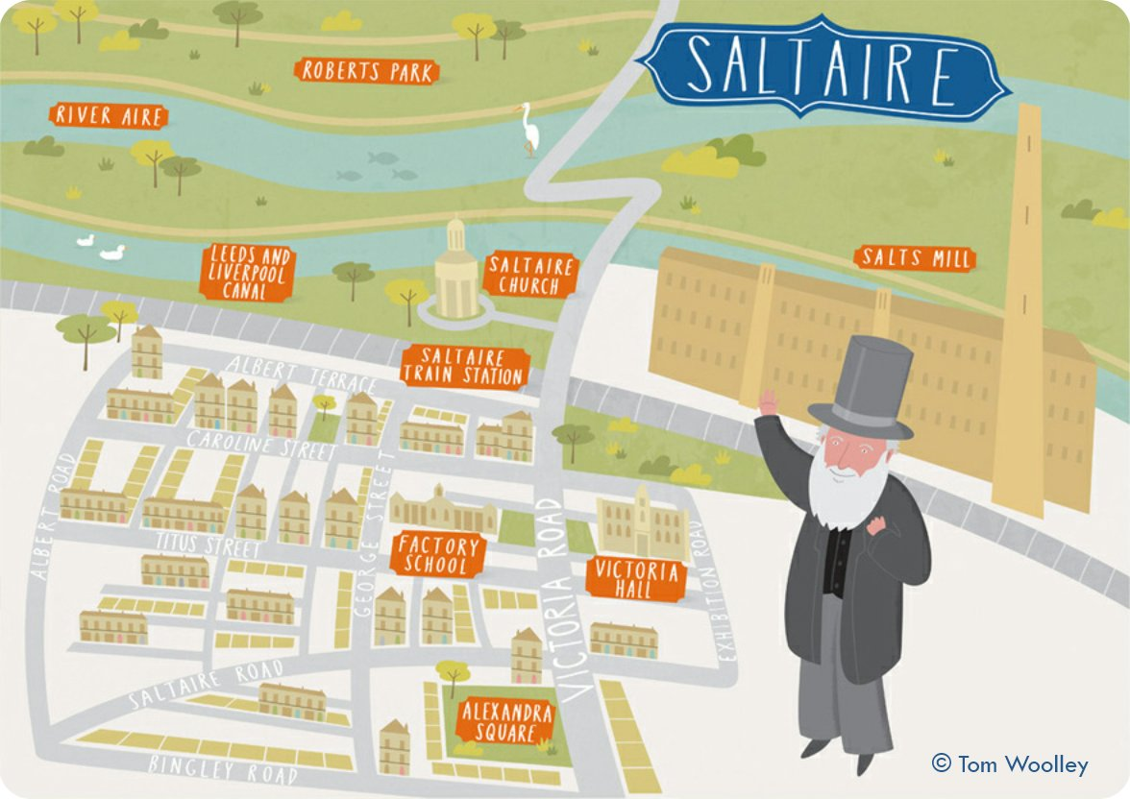

**Curriculum pathway:**

**Key Facts**

Saltaire was built by Sir Titus Salt to provide better living and working conditions for his workers.

Saltaire gets its name from Sir Titus Salt, and the River Aire which runs through it.

When Salts mill opened it was the largest mill in the world.

**History Year 4**

**Autumn Term – Our Magical City**

**Sir Titus Salt**

**Key Vocabulary**

Mill - a factory fitted with machinery for a particular manufacturing process

Textile – a cloth or woven fabric

Alms houses - house founded by charity, offering accommodation for poor people.

1. Tow path - a path beside a river or canal, originally used as a pathway for horses towing barges.
2. Alpaca - a long-haired domesticated South American mammal related to the llama, valued for its wool.

Mausoleum - a stately or impressive building housing a tomb or group of tombs

Infirmary - a place in a large institution for the care of those who are ill.

**Key Questions**

What was life like in Victorian Bradford?

Who was Sir Titus Salt?

Why did Sir Titus Salt build Saltaire?

Why did Sir Titus Salt name it Saltaire?

What was it like working in a mill?