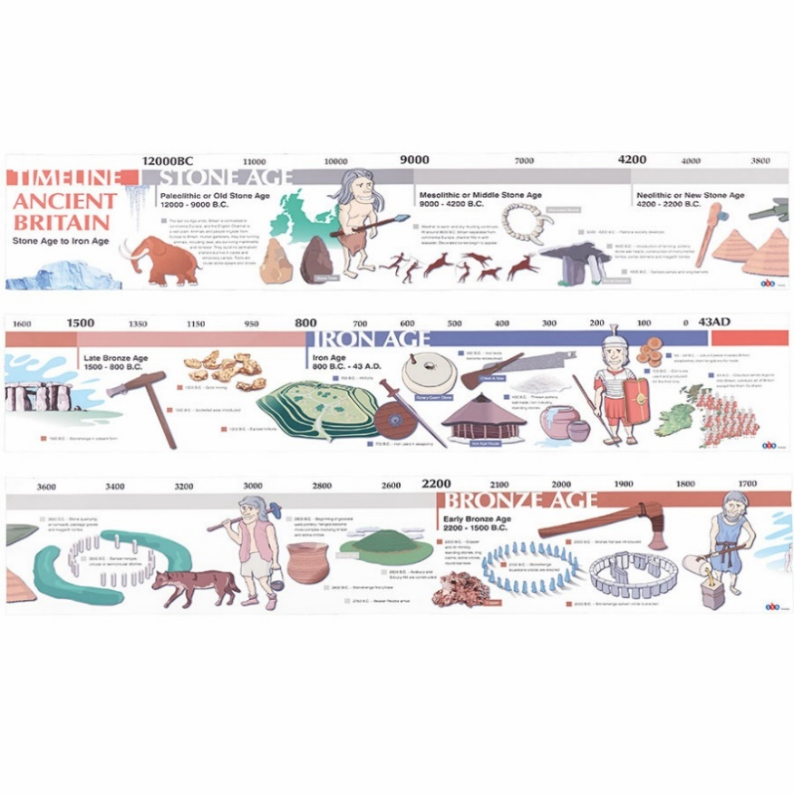

**Curriculum pathway:**

**Key Facts**

There were 3 periods of time during the stone age: Palaeolithic, Mesolithic and Neolithic

The Stone Age began about 2.6 million years ago.

When the first humans began to live in Europe they used stones as tools.

The Bronze Age began about 4000 years ago.

Metals were used to make hunting tools. Humans also began to farm land.

The Iron Age started between 1200 BCE and 1000 BCE

Humans used iron to make tools, and farmed land instead of hunting. They lived in communities.

**Key Questions**

What is a timeline?

When did the stone age, bronze age and iron age occur?

What were the tools like in those ages?

What were the houses like in those ages?

How do we know about life in the stone age?

**Key Vocabulary**

BCE – Before Common era

CE – Common era

Prehistoric – the period before written records

Timeline - a graphical representation of a period of time, on which important events are marked.

1. Hunter-gatherer - a member of a nomadic people who live chiefly by hunting and fishing
2. Artefacts - an object made by a human being, typically one of cultural or historical interest.
3. Roundhouse - an inn or club on a country road.
4. Druid - a priest or magician in the ancient Celtic religion.

Palaeolithic - relating to or denoting the early phase of the Stone Age, lasting about 2.5 million years

Mesolithic - the middle part of the Stone Age, between the Palaeolithic and Neolithic

Neolithic - the later part of the Stone Age, when ground or polished stone weapons and implements prevailed.

**History Year 3**

**Autumn Term – Who First Lived in Britain?**

**Stone age**