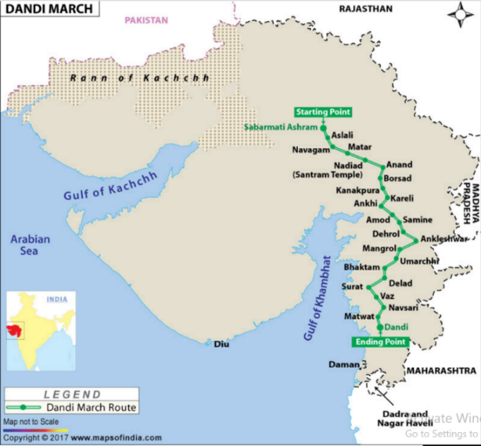

Experiences

**Curriculum pathway:**

**Key Facts**

Gandhi was born on October 2, 1869 in Porbandar, Gujarat, India.

When Gandhi was 18 years old, he went to [study law in England](https://kids.kiddle.co/England).

Gandhi started protested against segregation and became a political activist to change these unfair laws.

Ghandi protested without using violence and weapons.

During Gandhi's life, India was a [colony](https://kids.kiddle.co/Colony) of the [United Kingdom](https://kids.kiddle.co/United_Kingdom), but wanted [independence](https://kids.kiddle.co/Independence).

Gandhi is famous for working to achieve freedom and equality for all, in India and in Africa.

On the anniversary of Gandhi's birth, **Gandhi Jayanti** is celebrated.

People followed Ghandi 240 miles across India in protest. This was called the Salt March.

**Key Questions**

Who was Ghandi?

When did Ghandi live?

Why is Ghandi remembered?

What were the most important events in his life?

What were some of the features of the society when he lived?

How should we remember Ghandi and why?

**Key Vocabulary**

Independence – not being controlled or ruled by another

Racism – People treated unfairly due to skin colour or background

Revolution – Sudden change of leadership

Colony – Group of people from one country who go to live in another country

Protest – an organised, public demonstration

Freedom – To have the right to do or say as you like

Equality – Provide everyone the opportunity to reach their potential

Society – human beings living together

Activist – A person who tries to make the changes they want to see in the world

Segregation – Setting someone apart from others.

**History Year 1**

**Summer Term – Incredible India**

**Gandhi’s Campaign for Independence**