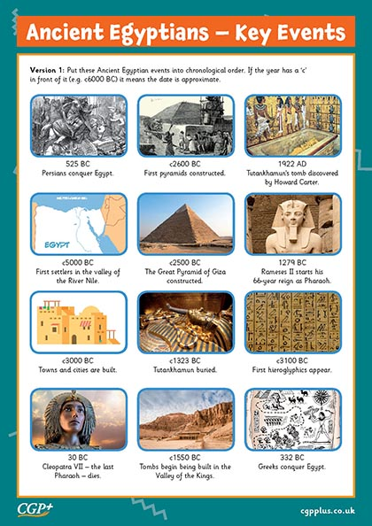

**Curriculum pathway:**

**Key Facts:**

Most Ancient Egyptian pyramids were built as tombs for pharaohs and their families.

Egyptians believed that by preserving a dead person’s body, through the process of mummification, their soul would live on in the afterlife forever.

The Egyptian alphabet contained more than 700 hieroglyphs.

Cats were considered sacred animals by the Ancient Egyptians.

Cats were believed to bring a household good luck.

**Key Vocabulary:**

Entomb - bury or trap within something

Sarcophagus - a stone coffin, associated with the ancient civilizations of Egypt, Rome, and Greece.

Scarab - The scarab beetle was one of the most popular amulets in ancient Egypt

Sphinx - a winged female monster in Greek mythology having a woman's head and a lion's body

Hieroglyphics - symbols or writing.

Mummification - the process of preserving a dead body as a mummy

Rosetta Stone - The Rosetta Stone is an ancient Egyptian stone bearing inscriptions in several languages and scripts

Cartouche - a carved tablet or drawing representing a scroll with rolled-up ends, used ornamentally or bearing an inscription.

Pharaoh - a ruler in ancient Egypt.

**Key Questions:**

How long ago was the Egyptian empire?

What was important to people during Ancient Egyptian times?

How does Ancient Egypt compare to other ancient civilisations?

What steps are required for mummification?

Who were the ancient Egyptian gods?

**History Year 6**

**Spring Term – Journeys**

**Ancient Egypt**