la piscina – swimming pool

una silla - chair

un sofa - sofa

una mesa - table

una nevera - fridge

un estéreo - stereo

un microondas - microwave

una alfombra - carpet

una lámpara - lamp

repite por favour – please repeat (formal)

repita por favour – please repeat (informal)

**Key Vocabulary:**

aqui esta – here is

una casa – a house

un piso – flat

bonito - pretty

magnifico – magnificent

enorme – enormous

lujoso – luxurious

arriba - upstairs

abajo - downstairs

la Ventana – the window

**MFL Year 6**

**Spring Term**

**House and home, Furniture**

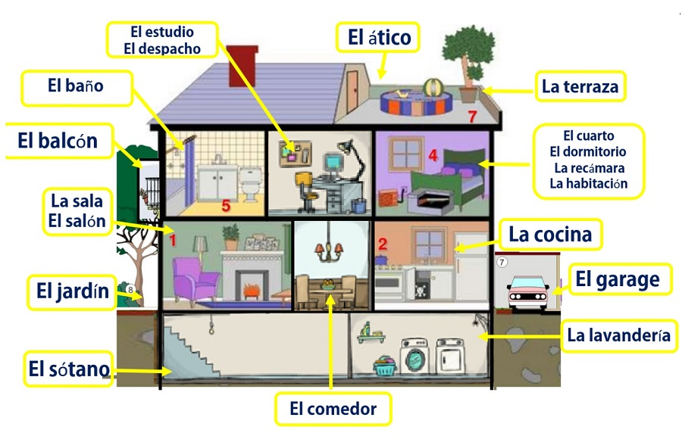

**Things I can already do:**

Follow a story as it is read aloud, demonstrating understanding

Listen for clues to meaning

Initiate and sustain conversations

Re-use previously learned language in a new context

Perform a sketch in Spanish to an audience

Present oral work confidently, speaking clearly and audibly with good pronunciation

Construct a short paragraph by adapting a model

Attempt accurate spellings when writing individual new words from memory

Understand key details from an authentic text

Understand the formation of a basic negative sentence

Understand that some nouns for occupations change their spelling in relation to gender

**Key Facts:**

In Spanish the adjective follows the noun.

**Key Questions:**

¿cuantas habitaciones tiene tu casa?