**MFL Year 4**

**Spring Term**

**Animals, Family members**

el padre - father

papa - Dad

la madre - mother

mama - Mum

el hermano - brother

el abuelo - Grandfather

la ebuela - grandmother

mi - My

si tengo – Yes, I have …

no tengo – No, I don’t have …

un conejo de indias – Guinea pig

**Key Vocabulary:**

El es – He is

Ella es – She is

Bastance - quite

Muy - very

simpatico - nice

pequeña - small

feroz – ferocious

divertido/divertida - funny

¿quien es? – Who is it?

y – and

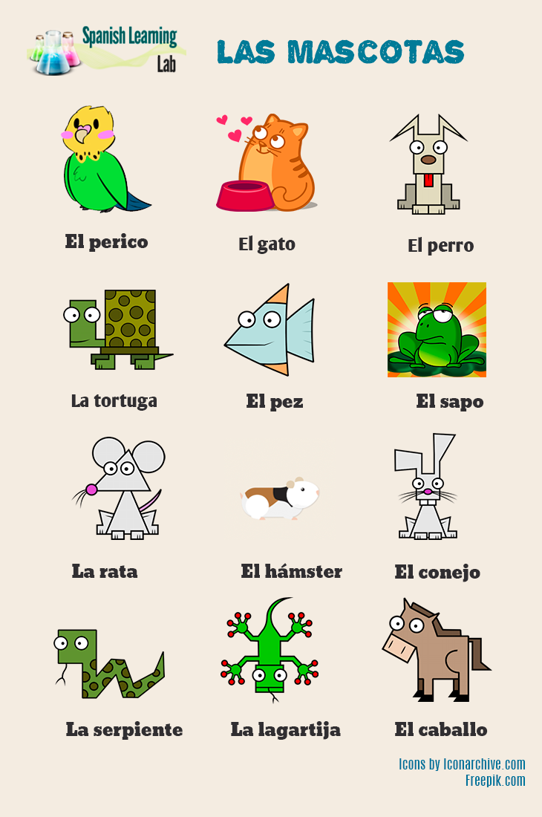

**un pájaro**

**el ratón**

**Key Facts:**

Plurals are usually formed by adding s but if a word ends in a consonant an es is added.

**Things I can already do:**

Listen to and follow a short story

Listen for specific words and phrases

Listen to and join in singing a Spanish song

Pronounce some words accurately

Ask and answer questions

Follow a short text as it is read aloud and demonstrate understanding of the text through drawing

Follow a story using visual clues

Scan a text to identify key words

Recognise some letters of the alphabet

Identify adjectives in a text and recognise that they can change spellings

Understand all nouns have a gender

**Key Questions:**

¿Quien es?

¿Tienes hermanos?

¿Tienes un animal?