**Key Vocabulary:**

Hay – There’s

un Mercado – a market

una tienda – a shop

un supermercado – a supermarket

una oficina de correos – a post office

un banco – a bank

un café – a café

una plaza – a square

una cathedral – a cathedral

una tienda de ropa – a clothing store

**MFL Year 5**

**Autumn Term**

**In the town, Time of day, Directions**

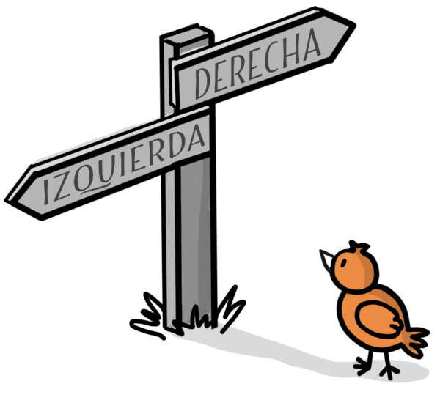

a la izquierda – on the left

a la derecha – on the right

en el centro - in the centre

aqui - here

está – it is

en la esquina – on the corner

por la mañana – In the morning

por la tarde – in the afternoon

por la noche – at night

a las diez – at 10 o’clock

a las cuatro y media – at half past four

bastante – quite

**Key Questions:**

¿Que hora es?

¿Hay un café por aqui?

**Things I can already do:**

Ask and answer questions

Attempt to write short phrases from memory

Read and understand a short paragraph with familiar vocabulary and structures

Identify a common sound in a list of verbs

**Key Facts:**

In Spanish the adjective follows the noun.