en otoño – in autumn

en invierno – in winter

en primavera – in spring

en Verano – in summer

vivo en – I live in

en el norte – in the north

en el sur - in the south

en el oeste - in the west

en el este – in the east

de Inglaterra - From England

**MFL Year 5**

**Summer Term**

**Food, Months of the year, Weather**

**Key Vocabulary:**

la leche - milk

el azúcar - sugar

los huevos - eggs

el agua - water

hace buen tiempo – good weather

hace sol – it’s sunny

hace mal tiempo – bad weather normalmente - normally

engeneral - generally

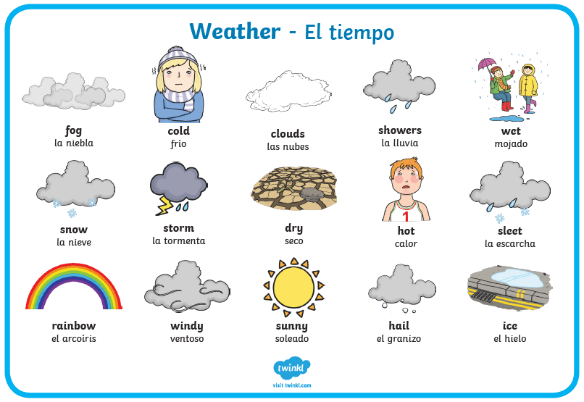

**Key Questions**

¿qué día es hoy?

¿Que tiempo hace?

**Key Facts:**

Sometimes the ‘h’ at the beginning of words is not pronounced.

**Things I can already do:**

Listen to a native speaker and understand more complex phrases and sentences

Understand more complex phrases, including comparisons

Take part in a simple conversation

Recite Spanish with accurate pronunciation

Extend basic sentences by using connectives

Express opinions

Develop accuracy in pronunciation and intonation

Write words and phrases using a reference