en barco – By boat

en coche – by car

en autocar – by coach

en tren – by train

en avión – by plane

un pantalón – a pair of trousers

una falda – a skirt

un pantalon corto – a pair of shorts

un jersey – a jersey

una camiseta – a T shirt

una camisa – A shirt

un sombrero – a hat

un bañador – a swimsuit

unas gafas de sol – sunglasses

**MFL Year 4**

**Summer Term**

**Likes and dislikes, Numbers to 30, Clothing**

**Key Vocabulary:**

bailar - Dance

nadar - Swim

jugar al fútbol – Play football

leer - read

Comer en un restaurant – Eating in a restaurant

Ver la tele – watch TV

ir al paque – Go to the park

Me gusta mucho – I like it alot

No me gusta – I don’t like it

me gusta - I like it

¿dónde? – Where?

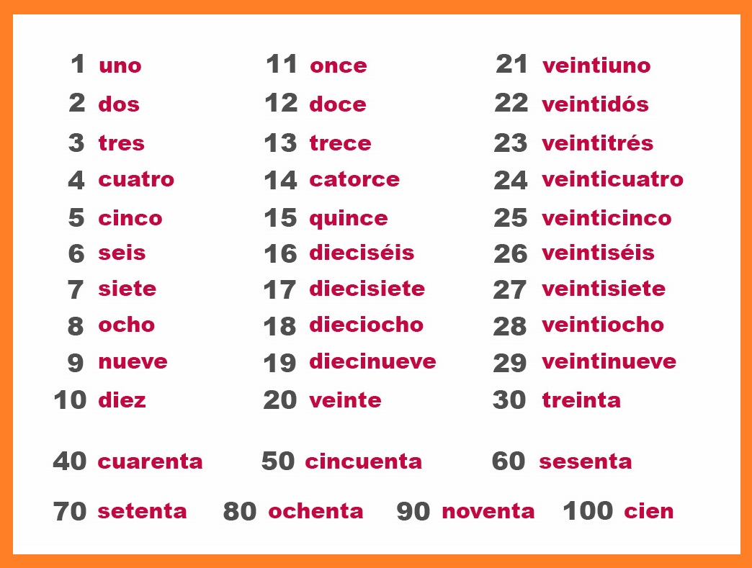

**Key Questions:**

¿Que te gusta hacer?

**Key Facts:**

‘v’ in Spanish is pronounced ‘b’

**Things I can already do:**

Say five vowel sounds in Spanish with support

Memorise and recite a short spoken piece

Communicate with others in Spanish

Ask and answer questions

Write a short sentence adapting a model, using noun, verb and adjective.

Order words to form a simple sentence

Read familiar words with accurate pronunciation

Join in reading repeated phrases

Recognise plural nouns