en avion – by plane

en coche – by car

en tren – by train

visitar – to visit

luego – then/next

el museo – museum

el Castillo – castle

la playa – the beach

el zoo – the zoo

el mercado - the market

el parquet – the park

**Key Vocabulary:**

vamos a – we are going to …

ir – to go

salir – to leave

estar – to stay

en - in

un hotel - hotel

un camping - campsite

comer – to take

en barco – by boat

**MFL Year 6**

**Summer Term**

**Planning a visit to a Spanish speaking country, The culture of the country**

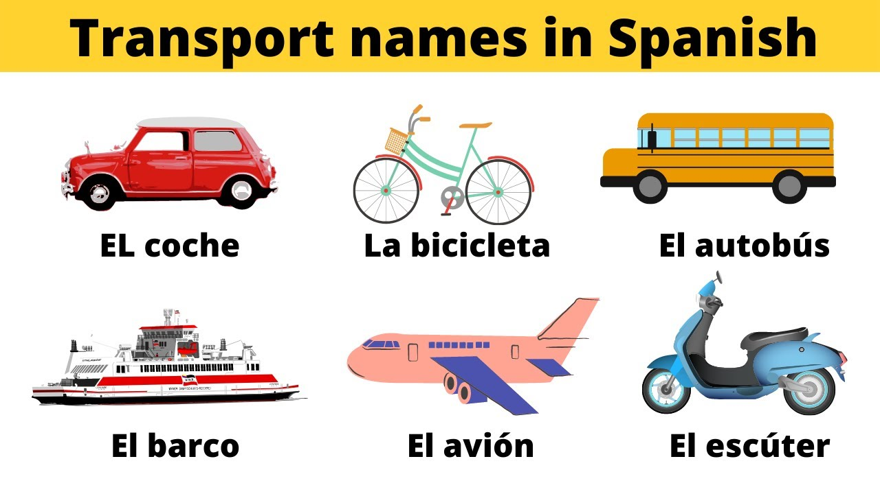

**Things I can already do:**

Understand the gist of an audio recording, matching adjectives to nouns

Work out how to pronounce unknown words

Recognise and practise the Spanish vowel sounds

Sustain an unrehearsed conversation of at least four exchanges

Produce own piece of writing, adapting a model

Identify the sounds of some letters of the alphabet

Identify and substitute nouns in a sentence

Identify nouns and adjectives contained in a text.

Read phrases with accurate pronunciation and with appropriate intonation and expression

**Key Facts:**

Spanish is the second most spoken language in the world

**Key Questions:**

¿A dónde vas de vacaciones?