**Curriculum pathway:**

**Key Vocabulary**

Commitment - doing what needs to be done regardless of your talents or your mood

Posture - the manner and position in which we hold our head, neck, back, and spine

Allah - the Arabic word for God

Qur’an - the holy book of Islam

Easter - Christian celebration of the resurrection of Jesus Christ.

Hot cross bun - spiced, sweet buns made with fruit and marked with a cross on the top

Crucifixion - the death of Jesus on a cross.

Resurrection - when God brought Jesus back to life

Suffering - going through pain, distress, or injury

Tomb - a place where a person is buried when they have died

Boulder - a large piece of rounded rock.

**R.E Year 2**

**Spring Term**

**Islam/Christianity**

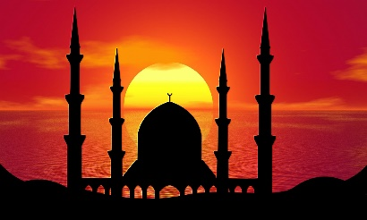

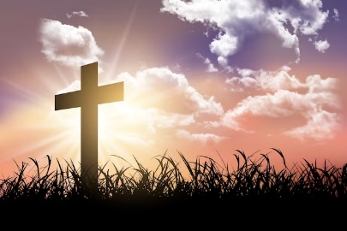-

**Key Facts**

Muslims pray 5 times a day.

Christians believe in Jesus’ resurrection as this proves to them that they can also have life after death.

Christians believe Jesus was given to people by God to die to rescue/save them from suffering because they do wrong things sometimes.

Christians believe Jesus was sent to ‘save’ people, forgive them for their ‘sins’ and offer them ‘salvation’ (life after death).

**Key Questions**

Does praying at regular intervals help a Muslim in his/her everyday life?

Who do I believe I am?

Does it feel special to belong?

How important is it to Christians that Jesus came back to life after his crucifixion?

Is God important to everyone?