**Curriculum pathway:**

**Key Vocabulary**

Brahman - one of the three major gods in the Hindu faith

Deities - a god or goddess, that is worshipped by people

Puja - making an offering of flowers or fruit to an image of a god

Trimurti - the three Gods in Hinduism

Omnipresent - being everywhere, all the time

Residents - people who live at a particular place for a long time or who was born there

Pilgrims - people who makes a long journey to a foreign land, sometimes for religious reasons

**R.E Year 3**

**Summer Term**

**Hinduism**

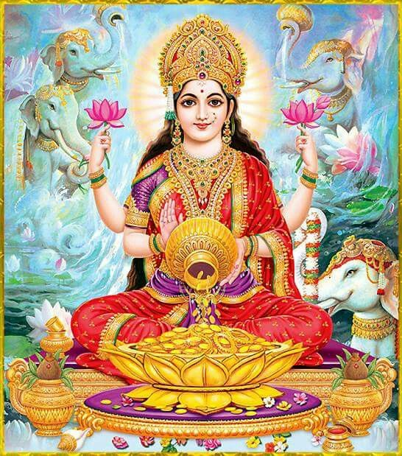

**Key Facts**

There is one God who Hindus see in many different forms: This God is called Brahman.

Hindus believe Brahman is in the water (a life source) helping them to get clean so they can be good people.

**Key Questions**

How can Brahman be everywhere and in everything?

Would visiting the River Ganges feel special to a non-Hindu?

Do religious people live better lives?

Is religion the most important influence and inspiration in everyone’s life?