**Curriculum pathway:**

**Key Vocabulary**

Evil - something which is bad or wicked

Belonging - fitting in or feeling like you are an important member of a group

Celebrate - to do something special or enjoyable for an important event

Prosperity - being successful, especially in making money

Temple - a building that people use for worshipping gods or for other religious purposes

Parcel - a package or a collection of things wrapped together.

Nativity - the birth of Jesus Christ, celebrated by Christians at Christmas

Carol - a joyful hymn or religious song sung a Christmas time

Shepherd - a person whose job is to take care of sheep and move them from one place to another

Wise men - men who travelled to visit Jesus after his birth, bearing precious gifts

Incarnation - the Christian belief that God took human form by

becoming Jesus

**R.E Year 3**

**Autumn Term**

**Hinduism/Christianity**

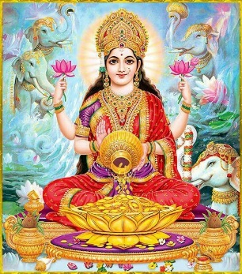



**Key Facts**

Hindus believe that they should try to bring as much good to the world as possible.

The goddess Lakshmi is worshipped to bring prosperity.

To Christians, Christmas is very important because they are celebrating God’s son, Jesus, coming to earth to help people.

Christians believe that in Jesus God came to live among humans.

**Key Questions**

Would celebrating Diwali at home and in the community bring a feeling of belonging to a Hindu child?

Does participating in worship help people to feel closer to God or their faith community?

Has Christmas lost its true meaning?

Do sacred texts have to be ‘true’ to help people understand their religion?

Is religion the most important influence and inspiration in everyone’s life?