**Curriculum pathway:**

**Key Vocabulary**

Miracle - a very amazing or unusual event, thing, or achievement

Medicine - something used to treat disease or illness

Healing - becoming well again, especially after a cut or other injury

Symbolise - the use of symbols to represent deeper meanings or themes

Palm Sunday - Jesus' triumphal entry into Jerusalem to celebrate

Passover before his death

Maundy Thursday - the day when Christians remember the Last

Supper, when Jesus celebrated the Passover meal with his disciples

Good Friday - a Christian holiday commemorating the crucifixion of

Jesus and his death at Calvary

Communion - when Christians eat bread and drink wine at church to remember the Last Supper

**R.E Year 3**

**Spring Term**

**Christianity**

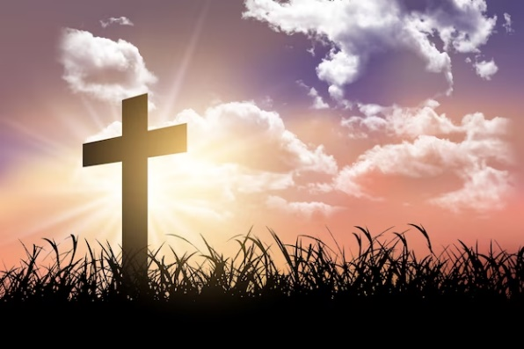

**Key Facts**

Christians believe Jesus is the Incarnation of God.

Christians believe it was possible for Jesus to perform miracles.

Christians believe God made a beautiful world, but when people started forgetting how to be good to each other and how to look after the planet, He sent Jesus to make things better, to save the day, to redeem the situation.

**Key Questions**

Could Jesus heal people?

Were these miracles or is there some other explanation?

Is religion the most important influence and inspiration in everyone’s life?

What is ‘good’ about Good Friday?

Should religious people be sad when someone dies?

Can the arts help communicate religious beliefs?