**Curriculum pathway:**

**Key Vocabulary**

Gurdwara - a place where Sikhs come together to pray

Respect - you accept somebody for who they are, even when they're different from you or you don't agree with them

Equality - the right of every individual to equal treatment and opportunities, regardless of factors like gender, race and social position

Organisation - a group of people who work together

Crisis - a difficult or dangerous time in which a solution is needed — and quickly

Treachery - not trusted or dangerous

Chapatti - a round flat unleavened bread of India that is usually made of whole wheat flour and cooked on a griddle

Evidence - something that is used to support an argument

Holy Week - a special week during which Christians can reflect on Lent and their faith before celebrating Easter

Betrayal - an act of deliberate disloyalty

Trial - the action or process of testing or trying

Jealous - thoughts or feelings of insecurity, fear, concern, and envy

**R.E Year 5**

**Spring Term**

**Sikhism/Christianity**

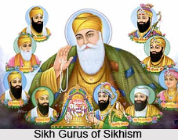

**Key Facts**

No new facts

**Key Questions**

Are Sikh stories important today?

How significant is it for Christians to believe God intended Jesus to die?