**Curriculum pathway:**

**Key Vocabulary**

Christians - Large group of religions who believe that the son of God was born a man - Jesus of Nazareth - over 2000 years ago

Creation - The making of the world by God

Precious - Something valuable and treasured

Bible - A sacred book that contains the word of God

Gold - A soft, yellow metal that is valuable

Frankincense - Sticky substance that comes from trees and

is burned giving off a nice smell.

Myrrh - A brown substance from trees in perfumes

**R.E Year 1**

**Autumn Term**

**Christianity**

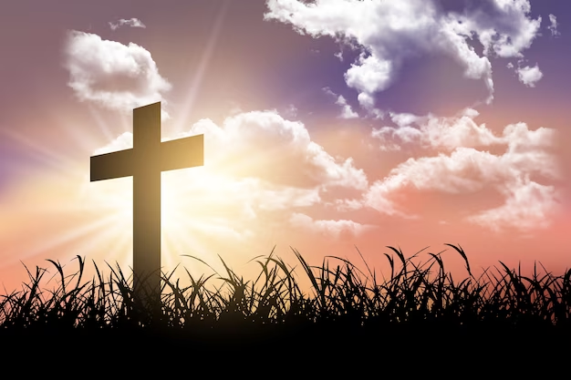

**Key Facts**

Christians believe that God created the world and everything in it

Christians believe that God wants people to look after the world as He has created it for them and gave it to people to enjoy and to look after for Him.

**Key Questions**

Does God want Christians to look after the world?

Does the world belong to God?

Should people take care of the world?

What gifts might Christians in my town have given Jesus if he had been born here rather than in Bethlehem?

What can I learn from stories from religious traditions?

Are symbols better than words at expressing religious beliefs?