**Curriculum pathway:**

**Key Vocabulary**

Shabbat - The day of the week set aside for worship and rest

Kippah - A small cap worn by Jewish men

Sabbath - The day of the week set aside for worship and rest.

Synagogue - A place of worship for Jewish people

Forgive - Choosing not to pay someone back when they hurt you

Rabbi - A religious Jewish teacher who is an expert in Jewish law

Shofar - A ram's horn

Repentance - To turn away from sin

Rosh Hashanah - The start of the religious new year for Jews

Challah bread - A loaf of braided bread that is made with eggs,

flour, yeast, and salt

Yom Kippur - The holiest day of the Jewish year

**R.E Year 1**

**Summer Term**

**Judaism**

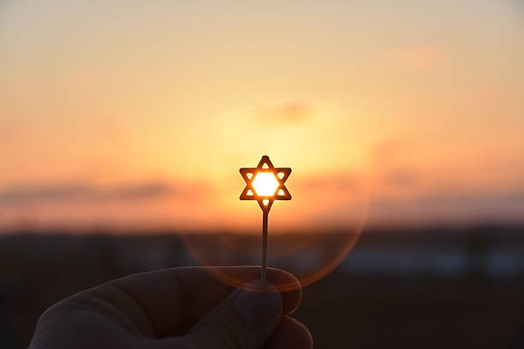

Experiences

**Key Facts**

Prayers are an important part of Shabbat.

Jewish people believe Shabbat is a time to be with the family and to thank God for everything.

At Rosh Hashanah Jews make plans for things they want to achieve in the coming year/ how they want to be/how to be better people, and ask God to help them.

The shofar is blown to mark the end of Yom Kippur

**Key Questions**

Is Shabbat important to Jewish children?

Are religious celebrations important to people?

Are Rosh Hashanah and Yom Kippur important to Jewish children?

Are religious celebrations important to people?

Are symbols better than words at expressing religious beliefs?