**Curriculum pathway:**

**Key Vocabulary:**

Canines - the pointy teeth that tear your food  
Molars - teeth with a rounded surface for grinding  
Incisors - teeth that help us to cut and chew food  
Oesophagus - a tube through which food passes from the pharynx to the stomach

Pharynx - part of the body that helps with eating and breathing

Intestines - organs or body parts that are shaped like long tubes  
Saliva - the clear liquid in your mouth that is made up of water and other chemicals

Vibrations - when objects make tiny and very fast back and forth movements  
Particles - smallest possible units of matter  
High pitched - made by fast vibrations and have high frequencies  
Low pitched - made by slower vibrations and have low frequencies

Frequency - the measurement of the number of times that a repeated event occurs  
Volume - how loud or quiet a sound is

**Science Year 4**

**Summer Term – The Great Escape**

**Sound**

**Animals including humans**

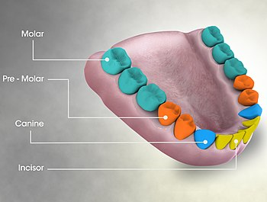

**Key Facts:**

We have three types of teeth - incisors, canines and molars.

The large intestine is around 5ft long and the small intestine is around 16ft long.

Sound comes from vibrations. These vibrations create sound waves which move through air and water before reaching our ears.

The pitch of a sound is how high or low the sound is.

**Key Questions:**

How many types of teeth do humans have?

What are the roles of the different types of teeth?

What happens to the food we eat?

How is sound created?

How does sound travel?

Does the size of an object affect the pitch of the sound it produces?