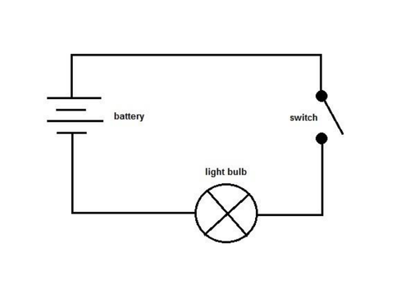 -

**Curriculum pathway:**

**Key Vocabulary:**

Alternating - the direction of the flow of electrons switches back and forth at regular intervals or cycles

Direct current the electrical current which flows consistently in one direction

Battery - a store of chemical energy

Motor - a machine that produces motion or power for doing work

Buzzer - an electric signalling device that makes a buzzing sound

Voltage - a measure of how strong the current is in a circuit

**Science Year 6**

**Spring Term – Journeys**

**Electricity**

**Key Facts:**

Lightning is caused by the discharge of electricity in the atmosphere.

Electricity was first discovered in 600BC by the Ancient Greeks.

Kilowatt is a unit used for measuring electrical power.

**Key Questions:**

How has electricity changed over time?

What are the different symbols on an electrical circuit?

What are the effects of differing voltages in a circuit?

What happens if you increase or decrease the voltage on differing parts of the circuit?