**Curriculum pathway:**

**Key Vocabulary:**

Force - Push or a pull  
Newtons - The measurement used to measure force  
Shadows - The dark shape made when something blocks the light

Reflect - To bend or throw back waves of light

Transparent - Light completely passes through, you can see clearly through it

Translucent - Some light passes through it but the light is scattered so you can’t see clearly through it  
Opaque - Cannot be seen through and does not allow light to pass through it

**Science Year 3**

**Summer Term – Greeks**

**Forces & Magnets**

**Light**

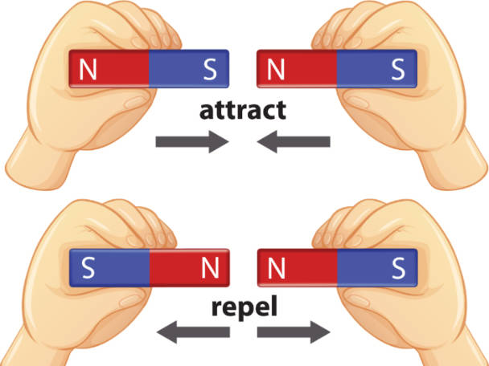

**Key Facts:**

Forces are the things that allow the movement of all objects around us.

Magnets have two poles; north and south.

Light is a form of energy that enables us to see the world around us.

Light comes from different sources.

Our main source of natural light is the Sun.

**Key Questions:**

What is a force?

Do things move differently on different surfaces?

What materials are magnetic?

Which magnetics poles attract and which repel?

What is light?

Which materials reflect light?