**Curriculum pathway:**

**Key Vocabulary:**

Circuit - a complete path around which electricity can flow

Cell - a device used to generate electricity

Crocodile clip - a clip that has jaws resembling a crocodile and is used to make temporary electrical connections

Switch - an electrical circuit that enables the flow of electricity to be turned on and off

Bulb - a small and simple light source

Conductor - the materials that electricity can flow through easily

Insulator - material that does not allow heat or electricity to pass easily through it

Component - a part or element of something

Classification - to arrange a group of people or things in categories based on their shared qualities or characteristics

Characteristic - the distinguishing features or quality of something

Organism - a term for any living thing

Amphibians - cold-blooded vertebrates (vertebrates have backbones) that don't have scales

**Science Year 4**

**Spring Term – 17th Century Britain**

**Electricity**

**Living things and their habitats**

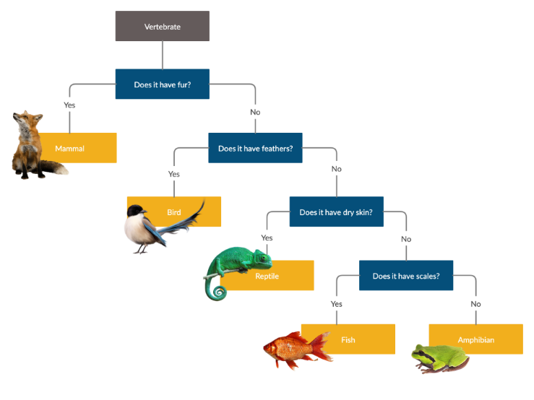

**Key Facts:**

Electricity is an energy. This energy can be used to power electrical items.

Electricity can only travel if there is a complete circuit.

A complete circuit is made up of different components -batteries (or cell), wires and bulbs, buzzers and motors.

An organism is an individual animal, plant, or single-celled life form.

A classification key is a series of questions that determine an organism's physical characteristics to help identify an unknown organism.

**Key Questions:**

What are the key components of a circuit?

Which materials conduct electricity?

Does the number of batteries affect the brightness of a bulb?

How can we group different living things?

What is a classification key?