**Curriculum pathway:**

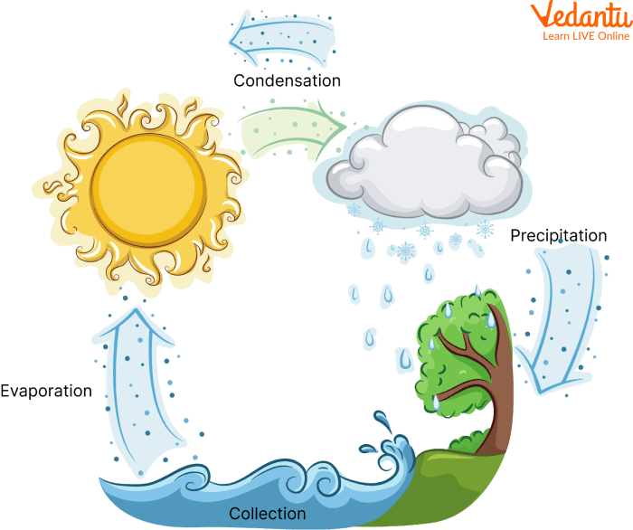

**Key Vocabulary:**

States of Matter - one of the ways in which matter can interact with itself

Solid - has a fixed shape and fixed volume

Liquid - substance where the particles are still close together but not as tightly bonded or in a fixed structure as a solid

Gas - a substance that has no fixed size or shape

Reversible - when materials can be changed back to how they were before the reaction took place

Irreversible - changes are permanent and cannot be undone.

Precipitation - any liquid or frozen water that forms in the atmosphere and falls back to the earth

Evaporation - when a liquid changes into a gas

Condensation - the process where water vapor becomes liquid

Filtering - a process by which impurities and particles are removed from either a liquid or a gas

**Science Year 4**

**Autumn Term – Our Magical City**

**States of Matter**

**Key Questions:**

What are the different states of matter?

How does a material change from one state to another?

How are clouds in the sky formed?

What temperature does water evaporate?

**Key Facts:**

Matter is another word for the stuff things are made of.

Everything falls into one of three categories; solid, liquid or gas.

Materials can change from one state of matter to another through freezing and melting.

The water cycle converts water into all three different states; liquid, solid (ice) and gas (vapour).

Clouds are formed after water from the earth is evaporated by the sun.

Vapour that has turned into liquid can be released by clouds in the form of rain or snow.