**Curriculum pathway:**

**Key Vocabulary:**

Wild – Something living in nature that is not looked after

Deciduous – Trees that lose their leaves in the autumn

Evergreen – Trees that stay green all year round

**Science Year 1**

**Summer Term – Incredible India**

**Plants**

**Seasonal Changes**

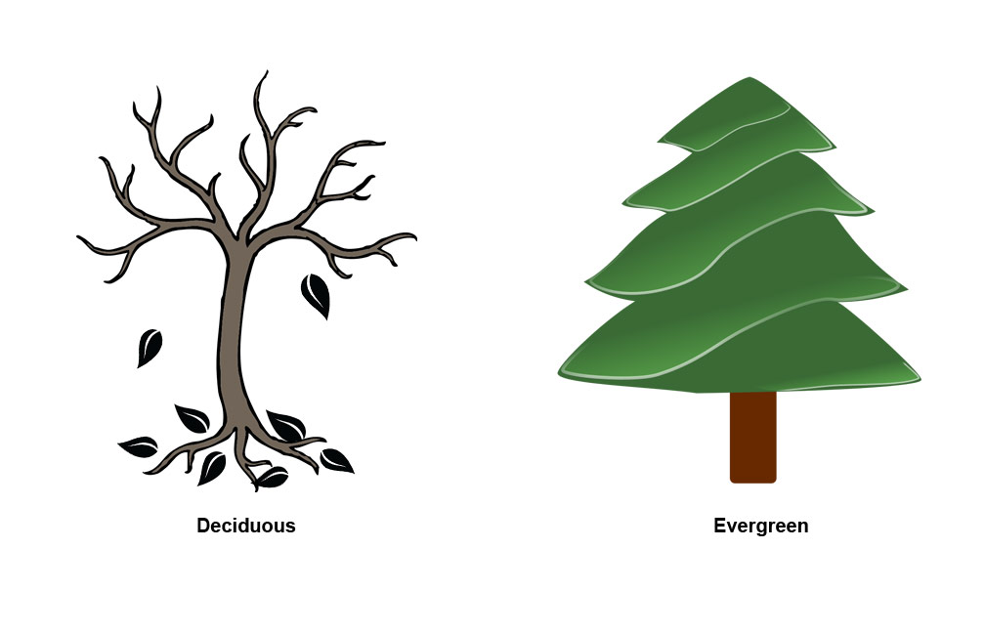

Experiences

**Key Facts:**

The four seasons are Spring, Summer, Autumn and Winter.

Flowers are made up of roots, stems leaves and flowers.

Plants need water, nutrients and sunlight to grow.

Summer usually is the hottest of the four seasons.

**Key Questions:**

What are the common, wild and garden plants and trees?

What are the four seasons?

How does the weather change in these four seasons?

What are garden and wild plants?

What is a flower made up of?

What do plants need to grow?