**Curriculum pathway:**

**Key Vocabulary:**

Metal – Materials like iron or lead that are found underground in rocks

Attract – To pull towards

Repel – To push something away

Wood – A material which comes from trees

Plastic – A manmade material from chemicals

Glass – A solid material that is hard and brittle

Fabric – A material produced by knitting or weaving fibres

Magnetic – A metal that attracts or repels other materials

Rough – Not smooth or even

Smooth – Not rough, even

Bending – Make something change its shape

Squashing – To crush something into a flat shape

Twisting – Repeatedly turn or bend

Stretching – To pull to fullest length

Brittle – Easily broken, cracked or snapped

Absorbent – Able to soak up liquid

Waterproof – A material that keeps water out

Environment – A place in which a person, animal or plant lives

**Science Year 1**

**Autumn Term – Castles**

**Naming and Identifying Materials**

**Seasonal Changes**

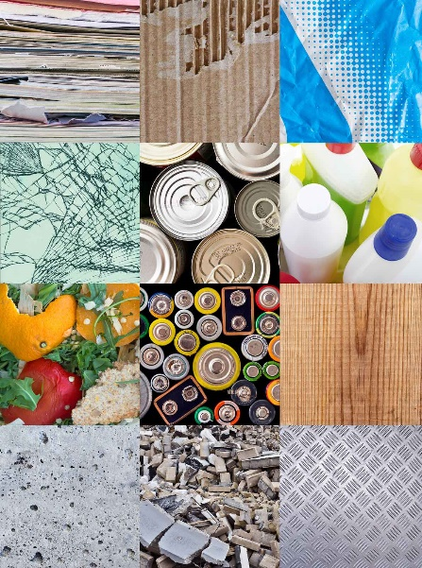

Sustainable development goals

**Key Facts:**

Objects are made from materials such as wood, fabric, glass, metal, cardboard, plastic or clay.

Some materials are magnetic.

Autumn is one of the four seasons of the year.

The coldest temperatures of the year are in winter.

**Key Questions:**

What are the properties of materials?

How can we change the shape of materials?

What changes can you see in Autumn and Winter?

What happens to animals in Autumn and Winter?