**Curriculum pathway:**

**Key Vocabulary:**

Solar system - consists of the sun and everything that travels around it

Orbit - a regular repeating path that one object in space takes around another

Planet - large or natural objects that orbit or travel around stars

Mercury - smallest planet in the solar system

Venus - the hottest planet in the solar system

Mars - the fourth planet from the sun

Jupiter - the biggest planet in the solar system

Saturn - the second largest planet in the solar system

Uranus - the only planet that spins on its side

Neptune - the eighth planet from the sun

Pluto - a dwarf planet

Rotate - to circle around a centre point

Axis - imaginary line an object turns around

**Science Year 5**

**Autumn Term – Adventures**

**Earth & Space**

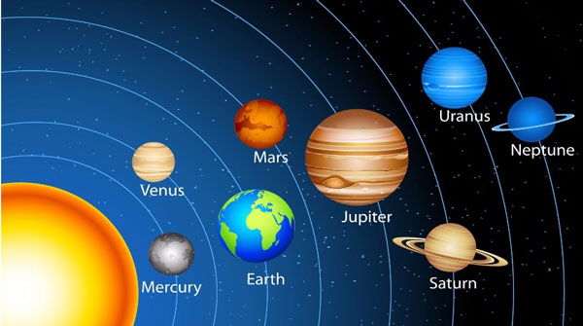

**Key Facts:**

A day is how long it takes a planet to rotate fully.

A year is how long it takes a planet to orbit the Sun.

The Moon has a diameter of 2,159 miles (3,476 kilometres) and is about one-quarter the size of Earth.

The Moon weighs about 80 times less than Earth.

Saturn is the lightest planet.

**Key Questions:**

How do we know the Sun, Moon and Earth are spherical?

What is the name of the planets in our solar system, in order?

What is the difference between heliocentric and geocentric ideas of planetary movement?

How do night and day occur?

Why does night time and day time occur at different times around the world?

How does the moon move in relation to earth?

How does the earth move in relation to the sun?