**Curriculum pathway:**

**Key Vocabulary:**

Bulb – Part of a plant mostly under the soil that stores food while the plant is resting from growing

Survival – The act of continuing to be alive or survive

Temperature – The amount of heat on something

Toddler – A young person usually between 1 and 3 years old

Teenager – A young person between 13 and 19 years old

Elderly – A older person

Offspring – Child or animal in relation to parents

**Science Year 2**

**Autumn Term – History of Flight**

**Animals including humans**

**Plants**

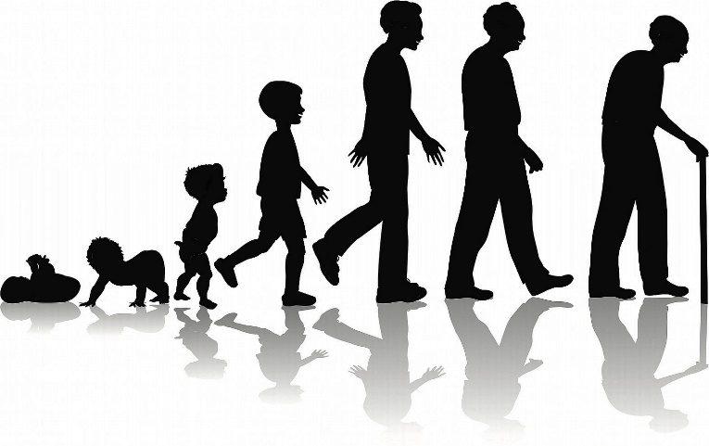

**Key Facts:**

Animals and human beings need food, water, air, and shelter to survive.

Humans can only survive without water for three days.

**Key Questions:**

What do animals need to help them survive?

How do humans change as they get older?

What are the offspring of animals called?

What is a bulb?

What do plants need to survive?